West Park Park play is helping the people of Wolverhampton meet, move, and play.
🎉 What is Parkplay? (Watch this 2 min video👉👉 What is Park Play)
What? Parkplay is FREE weekly community led fun and games in the park. It's relaxed, inclusive, and built on the simple belief that play is for everyone, helping people in the community come together, connect, and be more active.
Where? West Park, Find us on Field 1, near the tearooms. Enter West Park via Connaught Road, turn right, and keep walking. You'll spot the tearooms on your left and pass the toilet block on your right. Then keep an eye out for our green Parkplay flag on the left - that's us! Look out for people wearing Parkplay t-shirts.
When? Sat morning 10 am.
Who? Anyone is welcome - all children under 14 must be accompanied by an adult (18+) who will be responsible for their supervision and behaviour at all times
How? Simple - REGISTER FOR FREE HERE. https://events.park-play.com/west
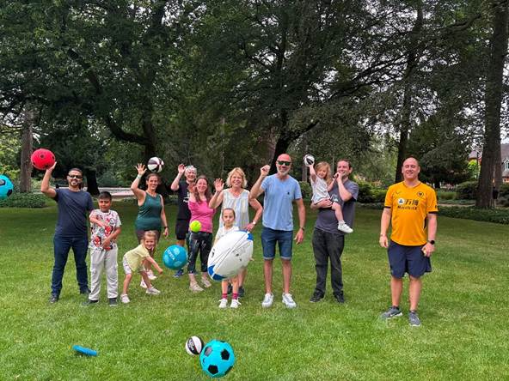How does Parkplay Help Community’s and People?
✅ Addressing Health Inequalities
✅ Create better connected communities
✅ Help them be more active whilst having fun outside in green spaces
✅ Improve physical and mental health outcomes
✅ Create volunteering opportunities and helping people improve their communication, organisation teamwork, and self-confidence
✅ Improving Park Safety and reduce Anti-Social Behaviour

For more information look at Home - ParkPlay
Thanks for your support in spreading the word about Parkplay.
Ben
Founder, Ignite Your Health CIC
Ben Mescam​​​​
Director
Ignite Your Health Community Interest Company | PA103 – Technology Centre | Wolverhampton Science Park | WV10 9UR
Telephone: 01902 244303

